MODULE 04 – Appendices
Since you were away for session four, you may want to review the following information on your own before we meet next time.
Part 1 – Preparing Our Hearts
Read the following scripture passage from Luke 10: 30-37 twice through.
Jesus replied, “A man was going down from Jerusalem to Jericho, and fell into the hands of robbers, who stripped him, beat him, and went away, leaving him half dead. Now by chance a priest was going down that road; and when he saw him, he passed by on the other side. So likewise, a Levite, when he came to the place and saw him, passed by on the other side. But a Samaritan while traveling came near him; and when he saw him, he was moved with pity. He went to him and bandaged his wounds, having poured oil and wine on them. Then he put him on his own animal, brought him to an inn, and took care of him. The next day he took out two denarii, gave them to the innkeeper, and said, ‘Take care of him; and when I come back, I will repay you whatever more you spend.’ Which of these three, do you think, was a neighbor to the man who fell into the hands of the robbers?” He said, “The one who showed him mercy.” Jesus said to him, “Go and do likewise.”
Take 3-4 minutes to reflect on your own on those questions, then share with someone if you like.
Guiding questions — Reflection on scripture
- The Samaritan knew where to find resources to assist the man who had been beaten. Where would you go to find resources to help your neighbour?
- Who is your neighbour? How can you show them mercy even in times of disagreement and conflict?
- What kind of care are we called to give our neighbour?
- How does your community (parish, neighbourhood, local schools, etc.) reach out to care for its neighbours, especially those who are sick, dying and passing on to eternal life? Share some examples.

Part 2 - Theological and ethical reflection
Watch the first video on Module 4 called “Theological and Ethical Perspective” .
Link https://www.cccb.ca/faith-moral-issues/suffering-and-end-of-life/horizons-of-hope-a-toolkit-for-catholic-parishes-on-palliative-care/module-4-supporting-and-integrating-within-the-wider-community/
If you prefer you can read the script for the video. In the course we watch the video, but we have found that when people reflect some like to go back and often read the script.
Video Script — Theological and ethical reflection
Members of a parish community cherish the feeling of gathering in their Church as members of the Body of Christ. As a community of faith, we are drawn together by our shared belief in Jesus Christ. At the parish, we are nourished and spiritually fed by the Eucharist, the Liturgy of the Word, and in the community where we gather. At the end of Mass, we are ‘sent forth,’ told to ‘go in peace!’ This is not just a signal to pack up and go home until next time: instead, it is our mission every day. We are called to live the Gospel in our communities and witness it in our families, workplaces, and in the wider society.
On the one hand, a parish community builds itself up internally seeking to grow spiritually. On the other hand, the parish community is often external, whereby parishioners provide support for people outside their immediate circle. Some parish groups are part of larger groups that contribute to the spiritual, political, and social good.
The Church has long emphasized the importance of caring for people at the end-of-life. We remember Saint Fabiola from the early Church, who founded one of the first hospitals in Rome; Saint Vincent de Paul, who is revered for his selfless dedication to the poor, or the three Augustinian sisters who opened the first hospital here in Canada, the Hotel-Dieu.
The Church has always encouraged us to perform the ‘corporal works of mercy,’ following Jesus’ words: “for I was hungry and you gave me food, I was thirsty and you gave me something to drink, I was a stranger and you welcomed me, I was naked and you gave me clothing, I was sick and you took care of me, I was in prison and you visited me.” (Matt. 25:35–36) This inspires us to offer accompaniment in many forms in solidarity with people at any difficult stage of life, including the end-of-life. The experience of people at the end-of-life is often a difficult one. The ill person can often be reluctant to ask for help because of concerns of being a burden. This self-perceived burden may create a sense of isolation from others, feelings of loneliness and despair, a sense of being disconnected from the rest of society. It can lead to the inability of both the dying person and the caregivers to have meaningful conversations. The dying person may distance themselves from others to reduce the perceived burden that they feel they are causing.
Sometimes the desire not to become a burden to others has the dying person become more focused on “keeping a positive outlook” when, more deeply, they may be scared of what is to come. They may not want to express their feelings for fear it would make it too difficult for those around them to cope with their illness. This situation can also result in the patient expressing their wish to die, stop treatment, or even request euthanasia. Often, when we need help the most, it’s most difficult to ask.
While these are not unusual or abnormal feelings, they are often challenging to cope with. We see an example of what a response might look like in the Parable of the Good Samaritan. Both a Levite and a Priest did not stop to help the injured and suffering man lying on the side of the road after being beaten and robbed. We can imagine that he was crying out for help. There is no explanation given in the story for why this occurred. Finally, a Samaritan traveller came upon the half-dead man and, moved by compassion, bandaged his wounds. In this instance, we see several things. The injured man needed help and was willing to take help from anyone, including a Samaritan. The Samaritan, too, was ready to put himself at risk in attending to an injured person who was considered unclean. However, the Samaritan, perhaps realizing that he could not continue to provide care, took the man to an innkeeper and asked for his help, saying that he would be back to pay for the care. This is significant in laying out what a compassionate response might look like and accepting the reality that we are not expected to “go it alone.”
This parable challenges us to consider what we as individuals and as part of a community of believers might do in responding to someone who needs our help. A concrete way we can respond is by deciding to join others in advocating for greater access to palliative care and end-of-life care to provide dignified surroundings for our loved ones as they confront serious illness.
By our presence and concern for those at the end-of-life, we can be present to help them with feelings of loneliness, hopelessness, abandonment, and grief. As members of the Body of Christ, we are called to pray for the sick, help them in spiritual and practical ways. We can assure them that they are not alone. The Sacrament of the Anointing Sick is a concrete way that the Church nourishes us and imparts special grace in serious illness and at the end-of-life. It is important that a Parish community continue to accompany caregivers and family members in the grieving process after the loved one’s death, consoling them and helping them find further counselling where that would be helpful.
Take 3-4 minutes to reflect on your own on the following questions, then share with someone if you are comfortable.
Guiding questions — Theological and ethical perspective
- How would you describe what it means to be a member of the Body of Christ?
- As an active part of the Body of Christ, how can you concretely help when there are people who require assistance? (ex. Gifts, charisms, expertise, time)
- What are some ways, big or small, that your parish community already reaches out to the sick, dying, and passing on to eternal life?
- How can you work with others in your parish community to reach out in new ways to support the sick, dying, and passing on to eternal life?
Part 3 - Medical Perspective
Watch the second video in Module 4 called “Medical Perspective” .
Link https://www.cccb.ca/faith-moral-issues/suffering-and-end-of-life/horizons-of-hope-a-toolkit-for-catholic-parishes-on-palliative-care/module-4-supporting-and-integrating-within-the-wider-community/
If you prefer you can read the script for the video. In the course we watch the video, but we have found that when people reflect some like to go back and often read the script.
Video script — Medical perspective
Accompaniment and Advocacy
As we have discussed in the previous modules, being with someone who is seriously ill or dying is a privilege. It can bring joy and fulfillment to both that person and yourself. The action of being present with someone can extend outside your close circle to your community, which can include neighbours, friends, co-workers and fellow parishioners. Being there and caring for others is what communities have done for thousands of years.
Being present with someone who is dealing with a serious illness, dying, caregiving or grieving is generally the same. It can include just sitting there with the person, listening to what they have to share, reflecting on fond memories, things that have brought them joy, and may include helping them with some tasks. This act of being present, while not necessarily easy, has been documented to have a positive impact on both the person and yourself.
And don’t forget to look after yourself as well. When holding vigil for many hours and days, it can be exhausting and you can get so tired that you cannot provide care or be present when it really matters. So take breaks, often. If there are other members of the family or friends, take turns holding vigil.
Remember, these tips for being present can apply in different settings and with a loved one or your broader community.
Grief and Bereavement
Losing someone is painful and difficult. The hurting, or grieving as we refer to it, usually starts before the person dies. It is the pain of seeing a loved one leaving us, not being able to do things we wanted to with the person, thinking of life without the person, among others. Speak to a close friend, or even your family doctor, nurse or counsellor, if you are having these feelings and they are stopping you from being able to function and do what you need to do in your everyday life.
The hurt will increase when the person dies. It is normal to feel the hurt; don’t hesitate to share with friends and caregivers the hurt you are feeling. Keeping it bottled up inside is not helpful and will harm you more in the future. It is often said that grieving does not go away, it just becomes easier to live with. You will experience increased feelings of loss on days and events that remind you of the person: their birthday, Easter or Christmas, an anniversary. Sometimes you will feel the person’s presence or even seem to see them. This is normal.
For some people, the grieving can be very difficult – so difficult that it stops them from being able to carry on with living, with work, caring for themselves, caring for others, being with others in the family. If you are feeling like this, do not hesitate to ask for help. Speak to your family doctor, nurse or counsellor, or call a help line or your local hospice for advice. It is not a sign of weakness. Even the strongest of people feel loss.
Research shows that some people are at even higher risk of experiencing very severe grieving. This includes situations where the loss is of someone much younger than you—a child or younger sibling, for example—or it was a sudden, unexpected loss, or it was the loss of someone you depended on a lot. Don’t hesitate to look for help.
Advocacy
Over the last four modules, we have shared many things about living and dying with serious illnesses and the role of palliative care. While today there are many more palliative care services—like hospices, palliative care units and palliative care teams in hospitals, the community and long-term care— than there were a decade or two ago, there are still many gaps and services lacking in many parts of the country.
Many parts of the country do not have enough positions for palliative care doctors, nurses and other key professionals like social workers and spiritual care providers and recreational therapists. There are large communities that do not even yet have palliative care units, or the funding for these units is being scaled back and they are being reduced in size or being shut down.
There are many communities that do not have hospices, and in many provinces, hospices still rely mostly on charity and fundraising. There are many communities that do not have access to palliative care specialists or to family doctors who are able to provide palliative care.
Most medical and nursing schools provide too little palliative care training, if any at all, even though access to palliative care is a human right, as declared by the World Health Assembly in 2014, which Canada is a part of.
There are education programs, such as Pallium Canada’s courses, that have been developed by Canadians, for Canadians, and are available across the country, but require ongoing funding to reach out to more doctors, nurses, social workers and other health professionals and students.
Become a champion and an advocate for more palliative care in our country. All Canadians should have access to palliative care: research shows that while it is good in some regions, it is lacking in many others; in fact, in some regions, less than 30% of people have access to it when they need it. Support any provincial or federal legislation that supports palliative care. Write to your local, provincial or federal elected officials. Ask them what support they are putting into local, provincial and federal palliative care initiatives. Remind them that most provincial governments and the federal government have identified the need for more and better palliative care. Now it’s time for action.
Thank you very much and God bless.
Take 3-4 minutes to reflect on your own on the following questions, then share with someone if you are comfortable.
Guiding questions — Medical perspective

- How can journeying with someone who is dying bring joy and fulfillment to both that person and you?
- How can you support those who are experiencing grief after a loved one has passed on to eternal life? What resources might you seek to assist you and the bereaved through their grief?
- How can you become a champion for palliative care in your local community, parish and family?

Part 4 - Community Perspective
Watch the third video in Module 4 called “Community Perspective” .
Link https://www.cccb.ca/faith-moral-issues/suffering-and-end-of-life/horizons-of-hope-a-toolkit-for-catholic-parishes-on-palliative-care/module-4-supporting-and-integrating-within-the-wider-community/

If you prefer you can read the script for the video. In the course we watch the video, but we have found that when people reflect some like to go back and often read the script.

Video script — Community Perspective

“Dying is not fundamentally a medical event, but rather a social event that happens in the family and the community.” This quote from Dr. Mary Lou Kelley reminds us that community involvement is an essential aspect of end-of-life. During this time, it is a chance for people to visit with the dying and the people caring for them, support the end-of-life team with food, groceries, supplies, prayer and care for others in the family, such as children and pets. This support is necessary throughout the dying process. Accompanying the bereaved is equally important after a person has died, so keep checking in with caregivers and family regularly (especially during the first year after the death, with all the firsts that family members will go through).

As we experienced during the Covid-19 pandemic, we could not connect and support the sick and dying with in-person visits. We needed to find creative ways to connect. The use of technology made it possible to support caregivers, the dying, and those grieving by using online video conferencing resources.
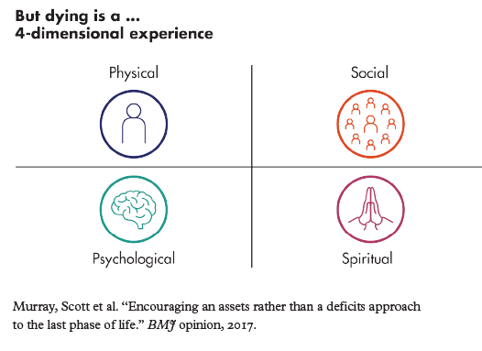

In Module 1, we learned about the three disease trajectories (the typical path a disease takes) from a medical lens, which focused on physical change. Dr. Murray, a family doctor from Scotland who is a leader in the field of palliative care worldwide, proposed that dying is a 4-dimensional experience that, in addition to the physical dimension, includes social, psychological, and spiritual dimensions. Understanding these three dimensions is essential for those who support the patient to ensure the patient lives well while dying. https://www.bmj.com/content/356/bmj.j878

Understanding how these three additional dimensions impact a dying person’s journey will allow us to understand better what the person is going through, when and how we can support them and their caregiver(s). There is a link in the take-home resources for this module to a video that describes the 4-dimensional experience.

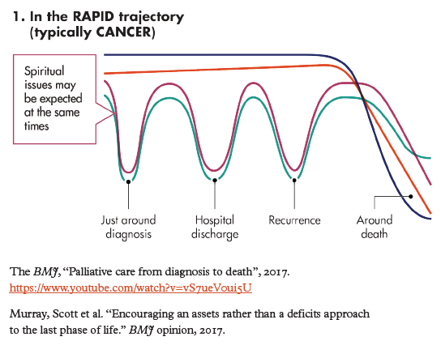
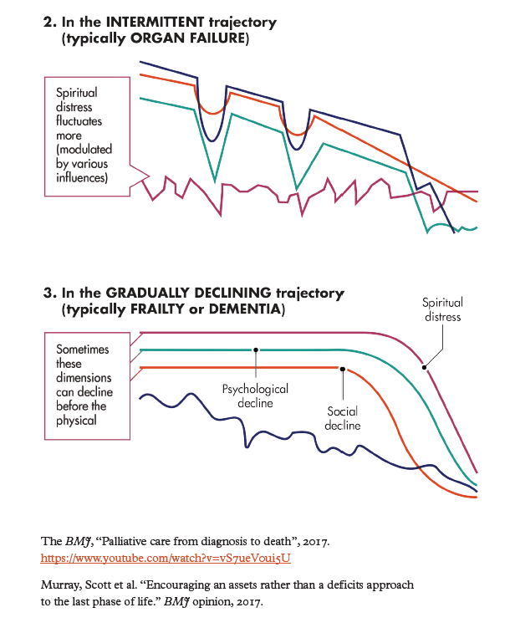
If a person’s wish is to die at home, it is essential that the end-of-life care team, which always includes medical staff, has a plan in place. The plan will guide decision-making, especially if things are not going well. This plan must include a 24/7 contact number for medical staff, especially if the team has concerns about the patient’s wellbeing. The end-of-life care team will strengthen the plan by taking scheduled shifts so that other team members can get some rest (even if they are resting in the house). This idea may be the most challenging part for some caregivers, as they may not want to leave the person’s side, but taking some time to rest will allow everyone to be present while on this journey. We have included a tool to help you develop an end-of-life plan in your take-home document.

In addition to the end-of-life care team, this is another excellent opportunity for family, friends, parish and community members to get involved and support. You might be asking yourself, “How much support do those facing a terminal illness need?” Let’s look at this image known as the care clock that shows how much time is spent with health care providers on average in the last 12 months of life.

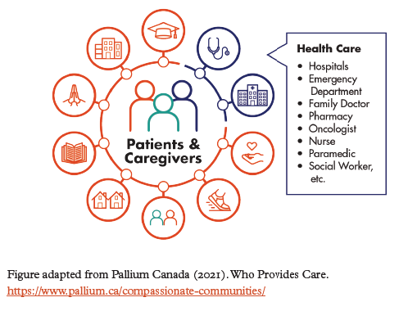

I wanted to take a moment to talk about accepting help and offering help since it is a key function of the support network for the patient and care team. When you want to offer help, be specific about the services and supports you are comfortable providing. The reason is, asking the person who is providing the care to identify things they need help with could be too much for them, and therefore they might respond with “Thank you, but we are fine.” So remember to offer specific help. No task is too small. Finally, we must respect the wishes of the patient and caregiver.

Please remember that friends, family, and neighbours genuinely want to support you. Often those accepting help feel like a burden; this is not true. By accepting assistance from others, you are allowing them to make a difference during this time.
I hope we have shown how community support can positively affect the patient and their care team. In times of need, supporting those around us comes naturally to parishioners since caring for the sick and dying is a requirement of the Gospel. Before there were sophisticated health care centres and advances in medical technology, families, friends, and neighbours were always ready to help the sick and dying. Today, people who live in large urban centres often feel isolated and alone. The movement to get communities engaged again in supporting people dealing with palliative care and end-of-life is essential.

You might be wondering, how do I or we breathe life back into the idea of the community getting involved again?

There are things you can do within your parish to support one another. Praying for the sick, taking Communion to them, arranging parishioners to make meals for the family, arranging for the priest to visit the dying person, and offering other benevolent gestures are ways that parishes can support their friends and neighbours.

You can do something in the broader community to empower more people to get involved and create a supportive community. If you are passionate about the power of community and want to explore how your community can take a more active role in supporting patients and their care team, learn more about the Compassionate Community movement at www.Pallium.ca .

You can find resources and tools to get you started, along with some Canadian examples of community activities in your take-home document for this session. Remember this: EVERYONE HAS A ROLE TO PLAY in caregiving, serious illness, dying and grief. What supportive role will you play?

Take 3-4 minutes to reflect on your own on the following questions, then share with someone if you are comfortable
Guiding Questions — Community perspective
- Reflect on how the dying process has changed during your lifetime. Was there a time when the community was more involved?
- Review the tool called Planning Guide for a Home Death (See handouts attached). If you have previously supported someone’s wish to pass on to eternal life at home, what areas from this guide do you think would have been helpful information to have?
- Do you feel your community is supportive of caregivers, those who are seriously ill or dying and those who are grieving? Are there areas where you think your community can improve?
- If so, share some examples with the group.
- Do you feel you have a role to play in supporting those who are caregiving, those who are dealing with serious illness or death and those who are grieving?
- If so, what supportive role do you feel you can play?

Take Home Information
Handout 1
SUPPORTING AND INTEGRATING INSIDE THE LARGER COMMUNITY
Question-and-answer take-home resource
As a community member, am I responsible for my neighbour?
- The Parable of the Good Samaritan provides us with insights into how we are called to help our neighbour in times of need. It reminds us that no matter who the person is, we must do the right thing and offer support and help where it is needed.
- Pope Francis, in his Encyclical Letter Fratelli Tutti, reminds us of this when he writes, …
  - love does not care if a brother or sister in need comes from one place or another. For “love shatters the chains that keep us isolated and separate; in their place, it builds bridges. Love enables us to create one great family, where all of us can feel at home … Love exudes compassion and dignity”. (no. 56)
What resources are available to help me understand or obtain palliative care in my community?
The Pontifical Academy for Life reminds us that “the Catholic Church’s appreciation for Palliative Care as an approach to caring for the vulnerable is evident in its catechism, which includes the following statement, ‘[Palliative care] represents a special form of disinterested charity, and as such, should be encouraged’.” (Catechism of the Catholic Church, n. 2279)
Pontifical Academy for Life, White Book for Global Palliative Care Advocacy, 15. https://www.academyforlife.va/content/dam/pav/documenti%20pdf/2019/White%20Book/WHITE%20BOOK%20English02%2025Apr19.pdf
The Pontifical Academy goes on to describe palliative care as providing relief to serious health-related suffering by “providing physical, psycho-social, and spiritual care to patients and their families.” (White Book for Global Palliative Care Advocacy, page 14)
- Look to health care professionals to recommend palliative care resources, such as medical home care, respite care and hospice care.
- Parishes, especially those that have parish nurses and pastoral care workers, provide support and guidance.
- To find local resources and other community supports, go to www.211.ca . This service is in 150 different languages; you can call and speak to an operator if that works better for you.
- Visit the Canadian Virtual Hospice to find supports for caregivers or for someone who is dying: www.virtualhospice.ca .
- Visit the Canadian Hospice Palliative Care Association (CHPCA) to find the location of palliative care wards in hospitals, residential hospices or hospice societies: https://www.chpca.ca .
- Each year the Catholic Women’s League of Canada presents a palliative care kit to assist members to participate in “12 Hours of Prayer for Palliative Care”. The event is held simultaneously with the Canadian Hospice Palliative Care Association’s National Hospice Palliative Care Week. See CWL 12 hours of prayer for palliative care for more information.

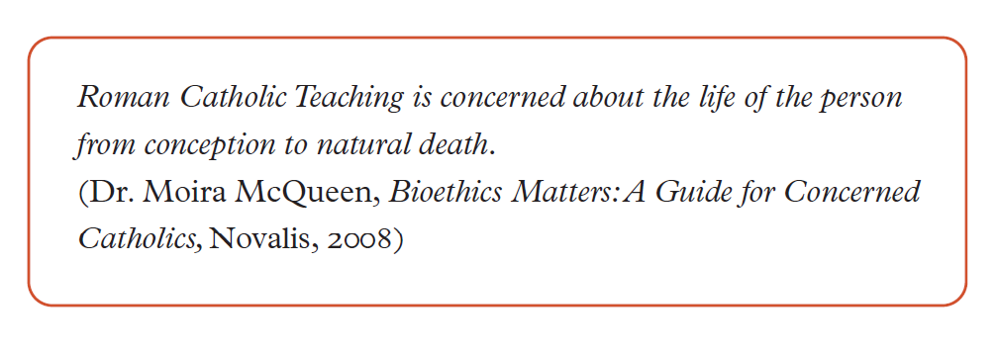
What can I do to support those in my community who are dying? How can I support their caregivers?
- Compassionate Communities is an excellent model for building support within one’s community: https://www.pallium.ca/compassionate-communities
- What is a Compassionate Community?
- A community of people who are passionate and committed to improving the experiences and well-being of individuals who are dealing with a serious health challenge, and those who are caregiving, dying or grieving.
  - Members of a Compassionate Community take an active role in supporting people affected by these experiences. This can be done through connecting people to helpful resources, raising awareness about life and end-of-life issues, and building supportive networks in the community.
  - While each community can adopt its own approach to building a more compassionate culture, there are common guiding principles for Compassionate Communities.
  - Members of a Compassionate Community recognize that:
    - Experiences of serious health challenges, caregiving, dying and grieving are part of everyone’s journey through life and that they can happen at any time.
    - Care for one another through these experiences is not a task solely for professionals; rather, everyone can participate.

To learn more and access resources to help you start your Compassionate Community, go to https://www.pallium.ca/compassionate-communities .

Here are some examples of activities running in Compassionate Communities in Canada:
- Compassionate City Crew — This is a program where volunteers work with each patient to identify the support that is needed and then create a team of support (patient’s family, friends, neighbours) and match them with the needs of the patient. This program in New Westminster, British Columbia, is partnered with the local hospice.
- Death: Something to Talk About — This program is a book club in partnership with the local library and hospice. Learn more by visiting McNally House Hospice.
- Bill’s Story — This video shows us how the community can support a dying person and their family along with the impact this makes: https://youtu.be/_5tJGaWjRZk .
- Living Well until the End: The Role of the Community (English and French; closed captioned) — This video with the Honourable Sharon Carstairs talks about palliative care and the role of the community in supporting those who are impacted by palliative care.
  - Care Connections —The Care Connections Program consists of a suite of resources and activities to support the millions of Canadians who are caring for their family, friends, and members of their communities. These resources are provided for free and are designed to empower every Canadian to better support the caregivers in their lives and to help strengthen the important social connections within our communities. To learn how to run a community workshop, go to www.pallium.ca .

What challenges could I face when helping those who are dying and their caregivers?

- The person who is ill may have stated that he or she wants privacy and is open only to having immediate caregivers, a spouse, children, close friend, doctor and nurse for assistance and support. It is important to respect those wishes.
- Ask the caregiver how you can support him or her. Try to be specific about what you can offer. Once your support is agreed upon, it is very important that you can meet the commitment you have made. Ask yourself, “What gifts, skills, knowledge can I offer as support to the caregiver?” Examples: Prayer, take Holy Communion to the caregiver and the person who is ill, walk the dog once a day, shovel snow after a storm, shop for groceries, assist with home maintenance (such as cleaning, small repairs), prepare and deliver meals.
- Be supportive by letting the family know that you are praying for them. This may be the most helpful and consoling support you can give.
Grief: What if I look back to a time when I cared for someone and have lingering doubts, worries or guilt about what happened? How can I resolve these concerns?
- Recognize and accept your sincere attempts to do your best during a challenging time.
- Pray about these issues.
- Don’t allow guilt and fear to become stumbling blocks to moving forward in freedom.
- Seek pastoral help and guidance from those who are knowledgeable about Catholic teaching on end-of-life matters and palliative care and whom you trust to listen with compassion.
- You may also find the Sacraments of Eucharist and Reconciliation very helpful.
- Join a support group for those who are grieving.
- Visit www.mygrief.ca to find resources to help you to understand and work through your grief.
- Visit www.kidsgrief.ca to find supports to talk with kids and teens about serious illness, dying and death. This is a great support for parents, families and teachers.
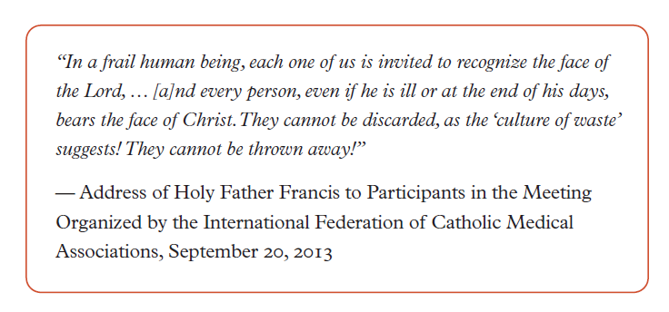

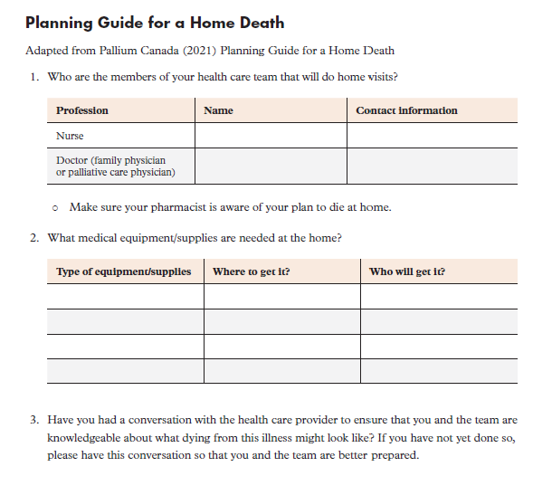

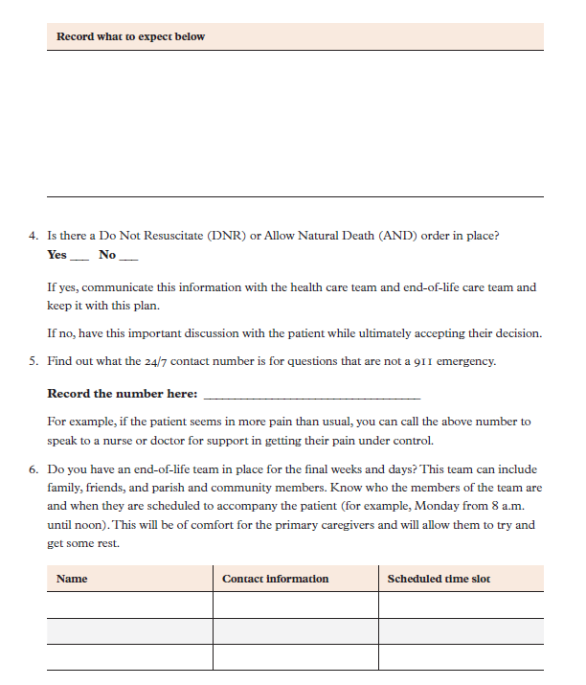

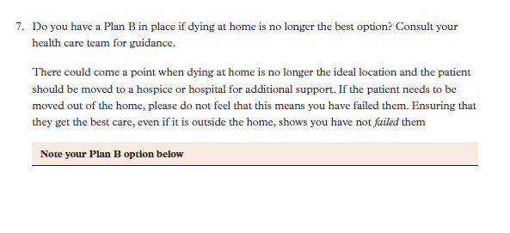

- Handout 2
Christian Funerals
Many people today, especially Catholics, have decided to plan their funerals. Planning one’s funeral does not have the same stigma as it once did. Some plan their funerals because family members may not share the same beliefs concerning life after death and the resurrection or may not be familiar with or sympathetic to Catholic funeral practices. Others wish to spare their loved ones the burden of planning a funeral. Sometimes there is no one to assume this responsibility.
Part of funeral planning involves burial plans. Many people have specific plans they want carried out, such as information on where they wish to be buried, or some people may consider becoming organ donors. Some do not wish cremation, and others do. It is important that the deceased person’s wishes are respected as far as possible.
Let us look at what is involved in a Catholic funeral to help with planning.
Who can have a Catholic funeral? A Catholic funeral is a celebration of our faith in the Lord’s mercy and kindness and is a sign of the hope and consolation we offer to those who are bereaved. A Catholic funeral is not a reward for a good life but an expression of the care of Christ and the Church for a member whose earthly journey has ended. The baptized and catechumens, saints and sinners, rich and poor, people who went to church every day and people who have not practised their faith in years are all members of the Church and can all have a Catholic funeral.
- Why have a Catholic funeral? A person may be tempted to spare friends and relatives the pain and expense of elaborate funeral ceremonies. But the bereaved may need this opportunity to express their loss and support for one another. Catholics are encouraged to experience the richness of traditional funeral and burial rites—to honour the deceased person and to comfort those who mourn. Ties of friendship and bonds of love do not and love we gave to the deceased throughout their last years and their final illness. Our prayers for the dead accompany them on their journey to God’s Kingdom and assure them of the support and presence of the Body of Christ that began at Baptism, was expressed in the Sacrament of the Sick, and was strengthened in Holy Communion throughout their lives and during their time of illness.

- Planning the funeral: The Order of Christian Funerals guides the Catholic community with specific rites and prayers to express consolation and hope to those who grieve, to give thanks to God for the blessings received by and through the deceased, and to ask God’s mercy on all sinners. It is designed to help those who are grieving to confront death in light of the life, suffering, death and resurrection of Jesus. “In the face of death, the Church confidently proclaims that God has created each person for eternal life and that Jesus, by his death and resurrection, has broken the chains of sin and death that bound humanity” (Order of Christian Funerals [OCF], 1).
- A Catholic funeral has three distinct parts. These give the bereaved time to begin to accept the reality of death, express their sorrow, reflect upon the deceased person’s life, give thanks to God, pray in light of Jesus’ resurrection, and find strength and consolation.

- The vigil: The vigil is an important moment in pastoral care for the living. The vigil allows the family, friends and the Christian community to face the reality of death and begin the process of grieving and healing. It is an opportunity to gather to remember the life of the deceased, express grief, and offer comfort and consolation. This is an essential part of the ministry of Christ that the Church offers to the bereaved. The vigil is usually held in a funeral home but may take place in the family home, church or other suitable location (OCF, 83). It includes a reading of the Word of God and prayers for the deceased and those who mourn. This is a suitable occasion for sharing stories and remembrances of the deceased. Even when the body of the deceased was buried shortly after death, was cremated, was donated for medical research, or was not found, the family is encouraged to gather for a prayer vigil. A picture of the deceased may be placed on a table with some flowers and a candle.

- The funeral Mass: “Christians celebrate the funeral rites to offer worship, praise, and thanksgiving to God for the gift of life which has now been returned to God, the author of life and hope of the just. The Mass, the memorial of Christ’s death and resurrection, is the principal celebration of the Christian funeral” (OCF, 5). In the funeral Mass, there is an emphasis on the Baptism of the deceased, since it is through Baptism in Jesus that each person receives the promise of eternal life. The white pall draped over the casket or urn, the holy water and the Easter candle are symbols of Christ’s life, which is bestowed through the waters of Baptism.

Readings chosen from Sacred Scripture are proclaimed at the Mass. Parishes and funeral homes often make resources available for selecting Sacred Scripture to those who will prepare a loved one’s funeral.

Words of remembrance or eulogies are not part of the funeral Mass. As regulations vary from diocese to diocese, the parish where the funeral Mass will take place will be able to provide helpful information on ways of including words of remembrance.

Homily: A brief homily based on the readings is always given after the Gospel reading at the funeral liturgy; it is not a eulogy. The homily is directed at helping all who are gathered to understand the mystery of God’s love and how the mystery of Jesus’ victorious death and resurrection were present in the life of the deceased and are present in our lives.

Music is an important element during the funeral. The words of the sacred hymns and songs in the parish’s music resources “express the mystery of the Lord’s suffering, death and triumph over death” (OCF, 30). Many dioceses have policies for music at funerals. The parish can advise on this.

Funeral outside Mass: When Mass cannot be celebrated, a funeral liturgy outside Mass may be used. A Mass for the deceased should be celebrated, if possible, at a later time (OCF, 12). A funeral liturgy outside Mass is ordinarily celebrated in the parish church (OCF, 350).

- The rite of committal: “The rite of committal, the final act of the community of faith in caring for the body of its deceased member (OCF, 377), is celebrated at the grave, tomb, or crematorium and may be used for burial at sea” (OCF, 512). Prayers are offered to commit the body to its final resting place. When the body has been or will be cremated, appropriate adaptations are made to the prayers of committal and signs of farewell.

Resources:
Catholic Funerals and Eulogies, the Pall and the Flag https://www.cccb.ca/wp-content/uploads/2017/11/Catholic_Funerals_and_ Eulogies_the_Pall_and_the_Flag.pdf

Sacred Scripture Selections for a Funeral Liturgy https://esubmitit.sjpg.com/cccb/index. aspx?component=ProductDetails&id=182-421%20
https://www.cccb.ca/announcement/cccb-releases-new-resource-for-planning-funerals-sacred-scripture-readings-for-a-funeral-liturgy/

Cremation:
Catholics and Cremation https://www.cccb.ca/document/catholics-and-cremation/

Cremation and Funeral Liturgies https://www.cccb.ca/wp-content/uploads/2019/12/185-134.pdf

French resources:
Passages De La Vie https://www.diocesemontreal.org/fr/passages-de-la-vie/deuil

La célébration des funérailles chrétiennes https://www.archtoronto.org/fr/our-faith/sacraments--sacramentals/funerals/

