HORIZONS OF HOPE – SESSION PREPARATION
- Decide on a time and dates for the 4 sessions (i.e. once a week for 4 weeks, twice a week for two weeks; weekday after morning mass; weekend; evening). Each session is 2 hours; we would suggest the last session be 2.5 hours.

- Place announcement in parish bulletin. As part of the announcements at mass, inform the parishioners about the workshop and how to register (i.e. leave name and email with the parish office). Offer to stand at entrance of the church after mass to answer any questions.

- Send an email to participants before the first session on when and where to meet and what to bring (pen).

- Download PPT, videos, and facilitators guide from the diocesan and/or CCCB websites
Be sure to download the following:

  - https://www.rcdvictoria.org/care-of-the-dying (diocesan website)
    - Diocesan introductory video (use this one NOT the one on the CCCB website). Looks like
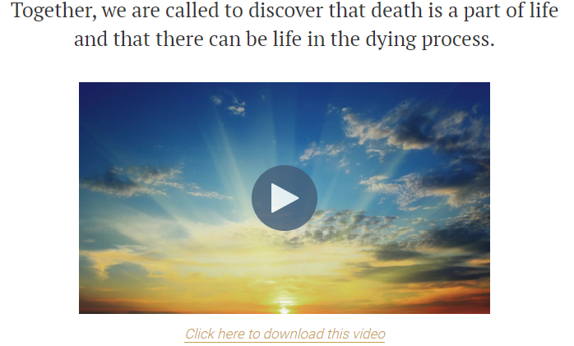
If you downloaded prior to June 2025 – note that it was updated slightly.
    - Download 4 PowerPoints – one for each session (developed by Bev and Claire from Holy Cross). Once downloaded you can use them as is or change them to suit your needs.
The PowerPoints have the notes of what to say with each slide (these are embedded into the note section that only the presenter sees). Feel free to change to suite your needs and presenter style. Much of the notes comes from the CCCB Facilitator’s Guide. The suggested time allotments are included for the silent reflection, small group sharing and group sharing.
  - https://www.cccb.ca/faith-moral-issues/suffering-and-end-of-life/horizons-of-hope-a-toolkit-for-catholic-parishes-on-palliative-care/ (CCCB website)
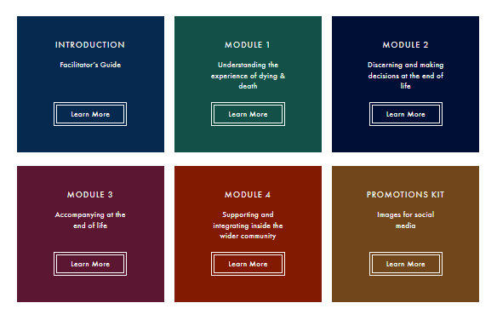
    - Download the Facilitator’s Guide – you should review it for ideas
    - Download the 4 Module Guides - you should review each Module Guide before you facilitate that session
Download each of the videos for each of the 4 modules to your computer (2 for each module and 3 for the last module) – this is better than having to access the videos on the internet during the sessions in case of a poor internet connection. Best to label each video in your video file for less confusion (i.e. 1A-Theoligical, 1B-Medical, 2A-Medical, 2B-Theological, etc.).
Alternately, the PowerPoints also have the videos hyperlinked to the CCCB website. This is not ideal as they do not allow you to go full screen when showing the videos, so we STRONGLY recommend that you download the videos to your computer (you will have to update the hyperlinks for each video).
- In preparation for each session – at the latest a few days before you present in case you need help with the technology:
  - Check that the technology is working:
    - Projectors and speakers (speakers loud enough for the room)
    - PowerPoint – so that you can see the notes section (presenter view on your computer and slides on screen that you are presenting on)
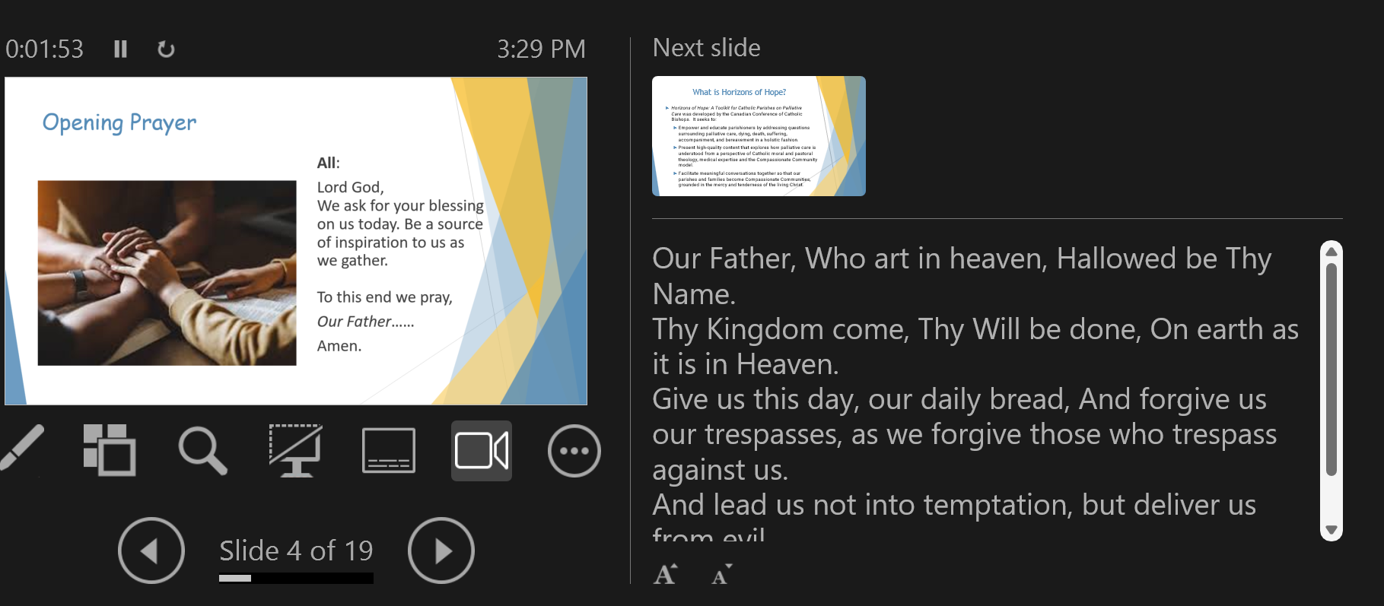

    - Check that video links in the PowerPoint are working and open to each of the videos stored on your computer. NOTE: If the links are not working, you will have to reset the hyperlink to the videos that are stored on your computer.

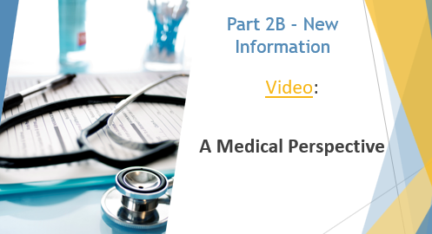

  - Print off the Appendices for each participant (or you could email to each participant); this is from CCCB materials.
    - Module 1 – Pages 26-42 plus one note page
    - Module 2 – Pages 28-46 plus one note page
    - Module 3 – Pages 24-38 plus one note page
    - Module 4 – Pages 34-62 plus one note page
We tended to give paper copies of the Appendices for each session at the start of each session (i.e. Appendices for Module 1 at the start of session 1; Module 2 at the start of session 2; etc.)
  - Have names tags and pens available for the days of the sessions

  - Optional: Consider inviting the pastor to come to the first 10 minutes of session 1 to help welcome everyone. Also invite the pastor to the end of the last session to help close session 4.

- Preparation on the day of the session or the night before:
  - Set up the room where you will be facilitating the session (chairs in a U-shape is nice for making people feel welcome; larger groups may need round tables and chairs)
  - Set up a prayer table (candle, bible, crucifix, etc.) in the space
  - Set up coffee, tea, water, etc. (and maybe cookies/treats) so people can help themselves at the break
  - Have ready handouts (appendices) and pens for each participant
  - Good to have a Kleenex box in the room somewhere (not uncommon for someone to cry at some point); may even want a Kleenex box at each small group
  - Again double check that the technology is working
  - Welcome people as they arrive and get them to put a name tag on
  - Start on time – end on time (this respects people’s schedules)
  - When breaking into small groups for the small group sharing, stay with 3 or 4 people (more than 4 people and people will not have time for everyone to share)
  - After each session clean up
NOTE:
- The biggest challenge can be reinforcing the Norms of Conversations (like Listening Circles). There is a slide in each PowerPoint on this. Stress to people that they are NOT to interrupt others (just listen) and to allow everyone to speak at least once before someone speaks again.

- Some people were unable to attend all four sessions, we just gave them the appendices and encouraged them to read them. The script for each video is included in the appendices. We created a special document to email participants that missed a session so they could work through it on their own. (see diocesan website for a copy)

- It is not uncommon for some people to cry as it brings up emotions of grief or sadness. If you have a large group you may want to provide a more private space for those that might need to take a private moment alone.

- Optional: After last session ask participants to complete the evaluation. They could fill in there or take home and drop off at the parish office later.

